Matrice 100 assembly
This checklist assumes that the UAS hardware has been configured in advance as required for the flight. The steps listed below are those that need to be done on site.

Check frame arms
- Ensure the motors are firmly attached to the frame arms and can rotate freely
- Ensure the landing gear is firmly attached to the frame arms and the antenna covers are in good condition

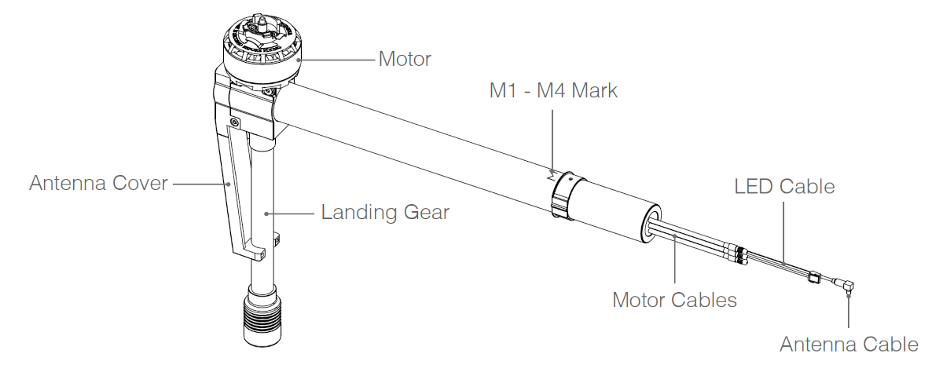
Figure 1. Frame arms (Matrice 100 User Guide, p. 5)

Check propellers
- Inspect the hooks inside the propeller nut and mounting plate for signs of wear and replace the propeller or mounting plate if necessary

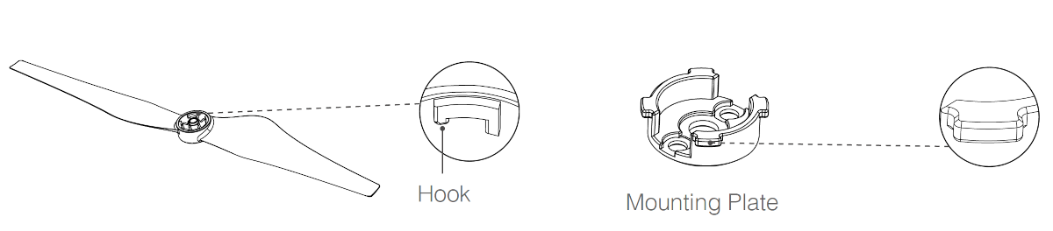
Figure 2: Propeller mounting (Matrice 100 User Guide, p. 18)
- Ensure the propellers are in good condition, especially along the leading edge of the blade. NO NOT USE damaged propellers.

Attach propellers
- Adjacent propellers rotate in opposite directions. Attach the propellers with a white dot onto the mounting plate with a white dot, and attach the propellers with no dot onto the mounting plates without a dot.
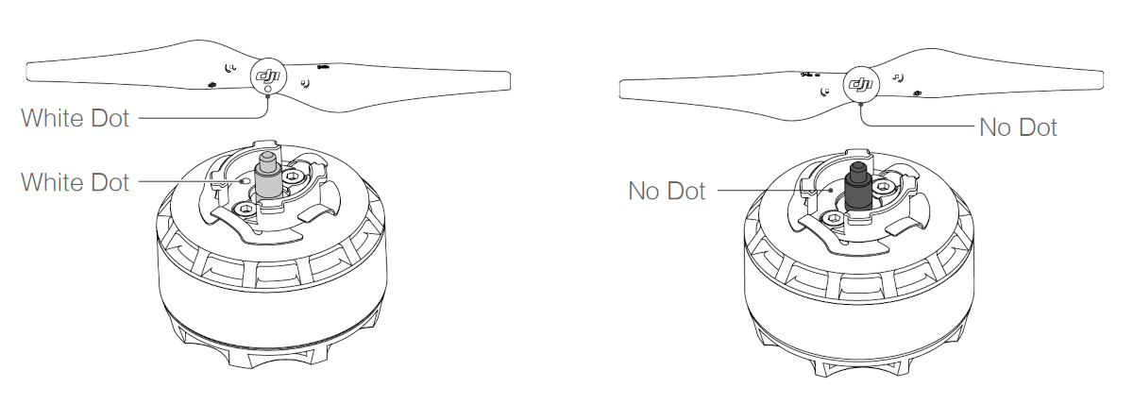
Figure 3: Attach propellers to the correct mounting plates (Matrice 100 User Guide, p. 18)

- Align the hook (A) with the securing spring (B). While pressing the propeller onto the mounting plate, rotate the propeller in the lock direction (indicated on the blade) until it is secured.
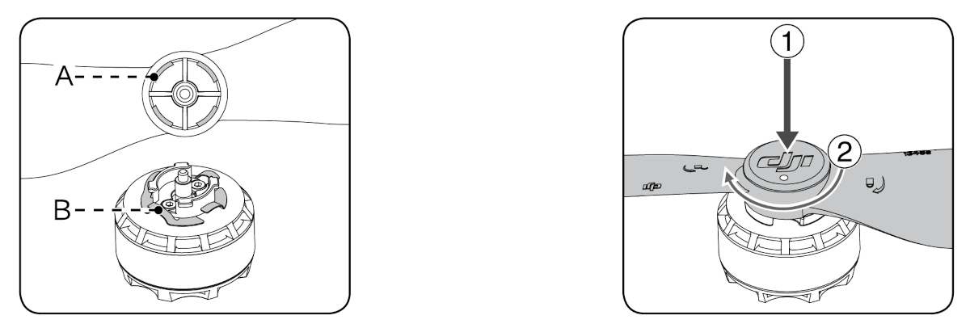
Figure 4: Securing the propellers (Matrice 100 User Guide, p. 19)
- Check that the propellers are mounted correctly by holding the motor in place with one hand and use the other hand to rotate the propeller in the unlock direction without pressing down. If the propeller can be removed this way, the propeller and/or the mounting plate may have become worn and needs to be replaced.

Mount the camera
- Remove the gimbal cover
- Rotate the gimbal lock to the unlocked position
- Insert the gimbal by aligning the white marks on the gimbal and gimbal lock
- Rotate the gimbal lock into the locked position
- Ensure the gimbal is locked securely and that the camera cannot be removed
- Ensure that the microSD card is inserted into the camera
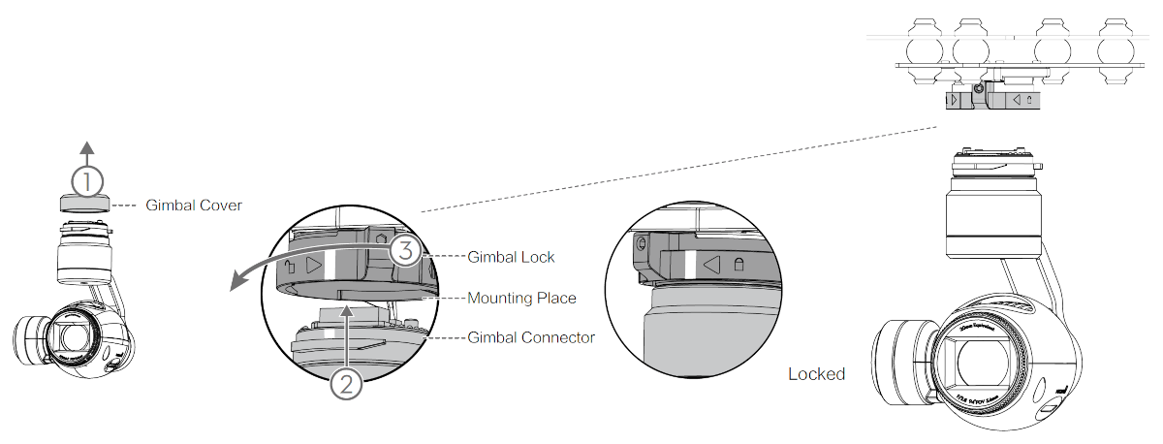
Figure 5: Attaching the camera (Matrice 100 User Guide, p. 22)

Installing the battery
- Ensure that the battery is powered OFF before inserting
- Insert the battery into the battery compartment
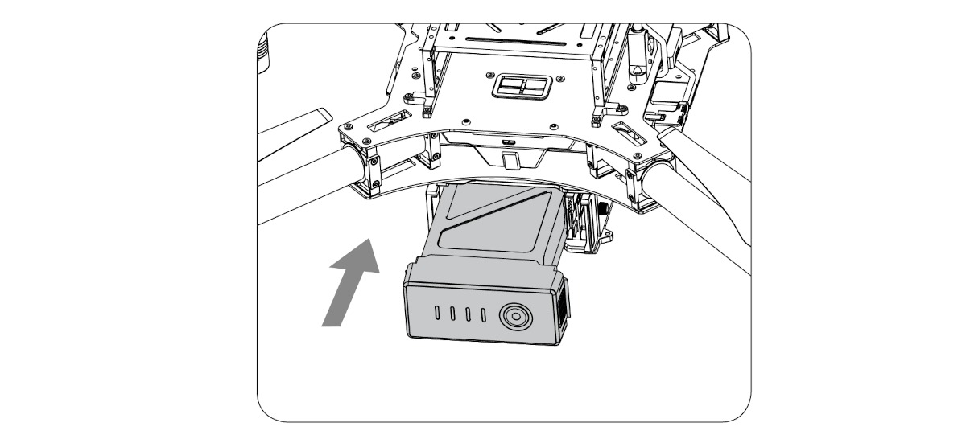
Figure 6: Inserting the battery (Matrice 100 User Guide, p. 24)
- Power on the battery: Press the power button once, then press again and hold for 2 seconds. The power LED will turn red and the battery level indicators will display the current battery level.
To power off the battery, press the power button once, then press again and hold for 2 seconds.
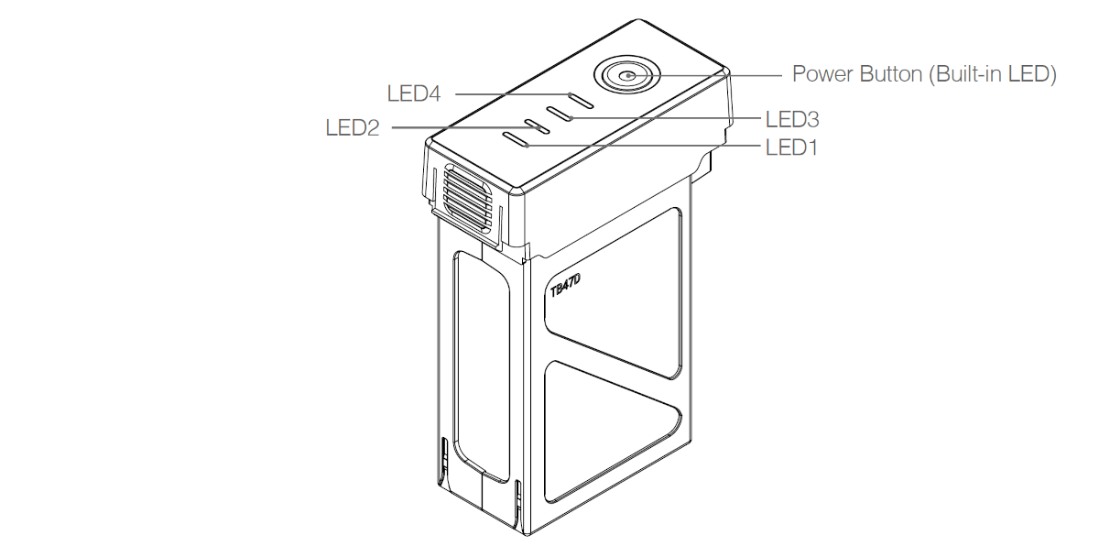
Figure 7: Powering on the battery (Matrice 100 User Guide, p. 24)

Disassembly
To disassemble, follow the steps above in the opposite order.
While doing so, check the equipment for signs of wear or damage and note these for maintenance before the next flight.
Pack the equipment carefully to avoid damage in transit.

